**Guidelines for Spectra-Based and Pixel-Based Normalization of TOF-SIMS Data**

**Scope and summary**

This code allows you to perform an automatized normalization of your ToF-SIMS spectra, either at the peak level (here what is normalized is the area underneath the peak) or at the pixel-by-pixel (image) level, and print/plot the results (box plots) in easy-to-handle formats. The code analyzes all the samples for which data are available at once, and for each sample it analyzes all the measurements performed, outputting the associated averages and statistics. For using this code, you need to have performed more measurements on each sample analyzed (for being able to perform some statistics).

This normalization approach can be performed using as a reference either the total ion (count or image) or a reference peak (or both in parallel).

The utilization of the code requires exporting your data in a readable format from SurfaceLab and organizing it in the given subfolders structure (“Data Exporting and Data Structure” section), entering some input in an Excel located in the same folder of the code/executable (“Code’s Inputs” section) and run the code (if you use the executable there is no need of installing anything).

When the code star it will print a message for your information (that will be closed automatically after a bit), and a second message (that will not close automatically) will appear as soon as the analysis is finished.

**Data Exporting and Data Structure**

Data should be structured in the subfolder structure shown in Figure 1.

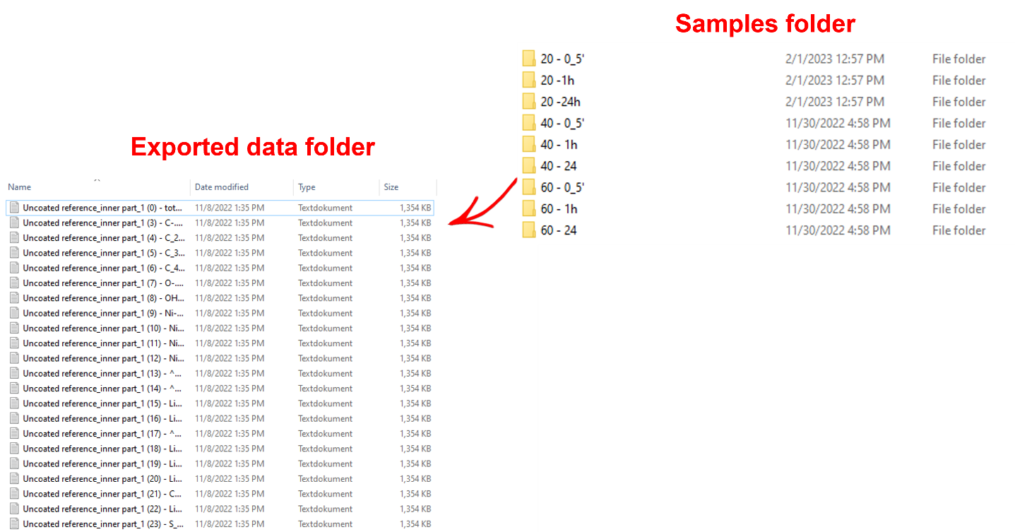

**Figure 1.** Schematics of the subfolder organization required for this code to work. The example refers to the pixel-by-pixel (image) code, for which one file is exported per each peak per each measurement (see below). In the case of the spectra normalization, in each folder there will be contained one file per measurement.

The procedure needed to export the spectra in a readable format is schematized in Figure 2. Through this procedure, you can export at once the spectra of all the measurements you want to analyze.

In addition to the spectra, the mass interval list you want to use should also be exported in a readable format. For doing this, you can open the “Peak list” widget (In Surface Lab) and then click on “Export peak list as/Ascii”.

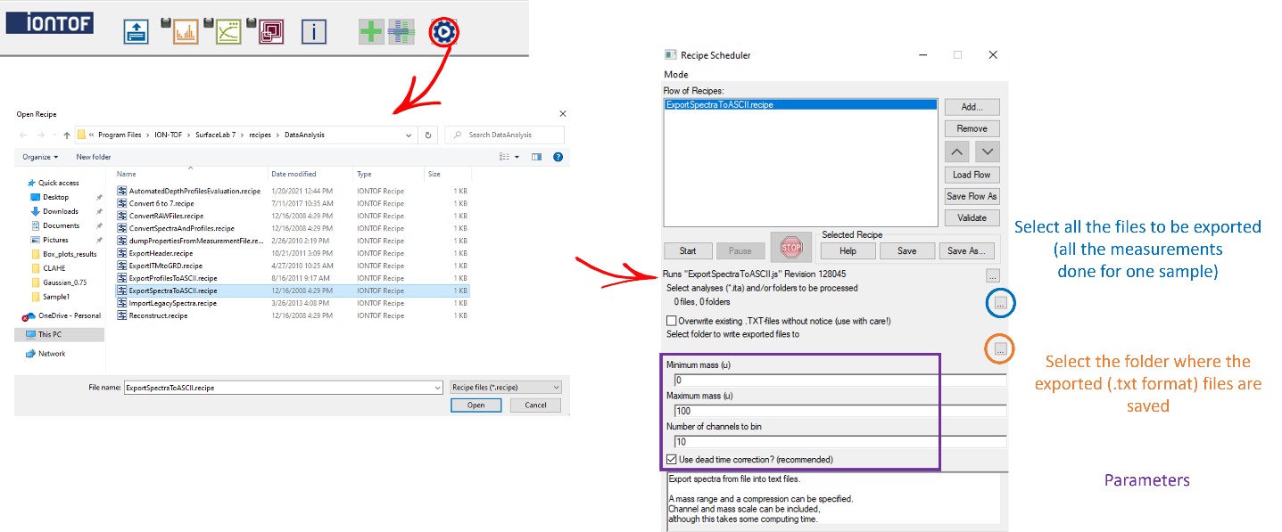

**Figure 3.** Schematics of the procedure to be followed in SurfaceLab to export the spectra of all the measurements you want to analyze.

The procedure needed to export the image data in a readable format (“Ascii”) is depicted in Figure 3. It should be underlined that this procedure allows exporting all the images of a given measurement, but it should be performed manually for all the different measurements and ***all*** the data associated with the same sample (here different measurements stand for analysis on different spots of the same sample) should be reported in the same folder (bottom left of Figure 1).

When exporting the images in this way, please be sure that you are coherently using the exact same mass interval list for all the measurements/samples you want to account for in the analysis.

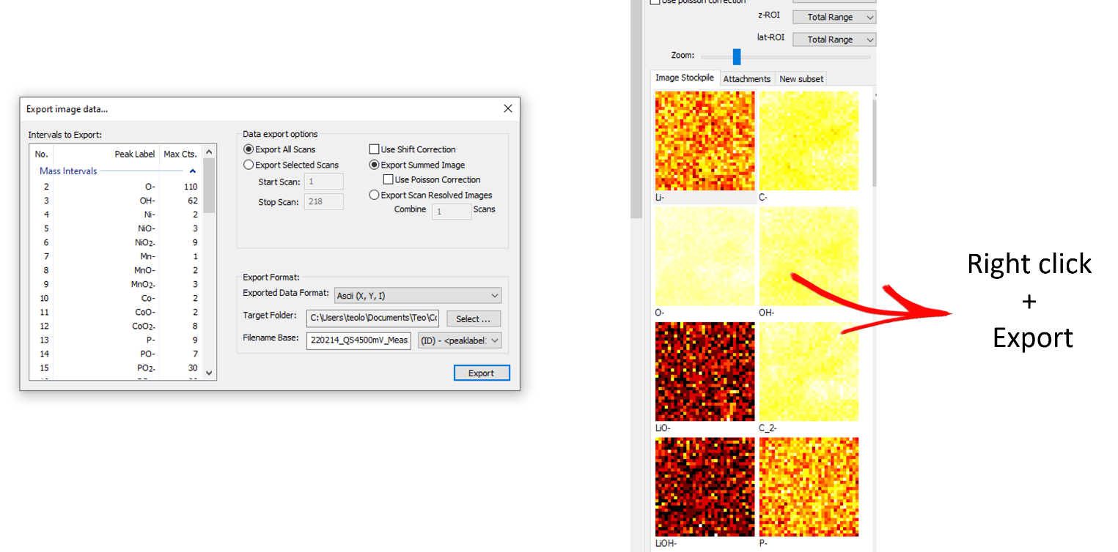

**Figure 3.** Schematics of the procedure to be followed in SurfaceLab to export all the images associated with a given measurement in a data readable format (“Ascii”).

**Code’s Inputs**

The code inputs need to be reported in the associated Excel file (one for the spectra- and another for the image-based code). The Excel file should be located in the *same* folder containing the executable/code file.

A schematic of the parameters (image-based code example) is reported in Figure 4.

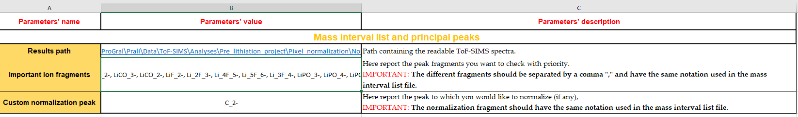

**Figure 4.** Example of the Excel input file (Image case).

In general, each parameter is associated with a devoted and complete explanation in the Excel file (Inputs.xlsx), which however is also summarized below.

**Result path**: Here you should indicate the complete path to the root folder (top left in Figure 1). This parameter is mandatory.

**Mass interval list**: Here report the name (including the file extension, *e.g.*, .txt) of your mass interval list (spectra-based analysis only).

**Important ion fragments**: Here you can (optional) list the most important ion fragments for your analysis (the associated results will be stored separately from the other peaks of your mass interval list, to ease your analysis afterward).

**Custom normalization peak**: Here you can (optional) indicate the name of the peak you want to use for custom normalization (in addition to the total ion image normalization, which is done by default). Please note that you should indicate the name exactly as reported in the extracted Ascii file (bottom left of Figure 1), in which the upper-case letters/numbers are indicated by “^”, while the bottom-case letters/numbers are indicated by “_”. Example: NiO_2-.

**Results**

Once the analysis is finished (and for both, surface-based and image-based codes), the results are stored in a new folder named “Box plot results”, whose substructure is shown in Figure 5.

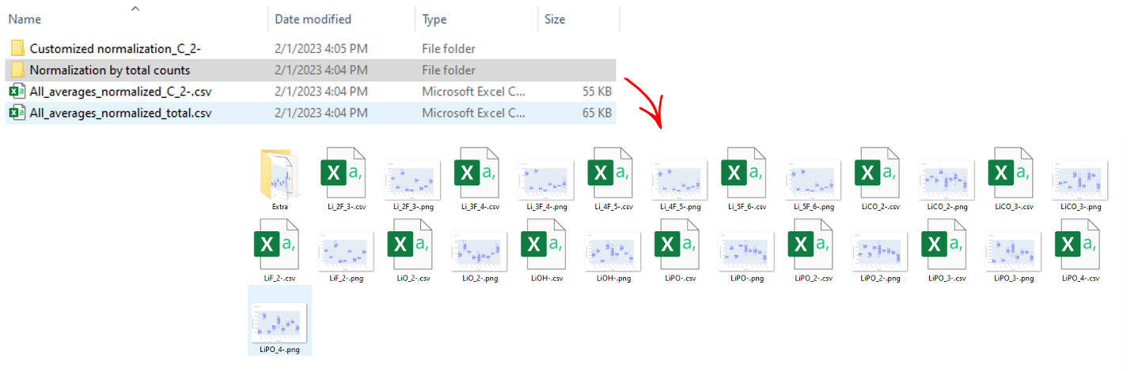

**Figure 5.** Example of results obtained by either the spectra- or the image-based codes.

The results folder contains one file per each normalization approach used (total ion plus, if indicated, the custom normalization peak) containing a summary of all the results for all the peaks analyzed, and a folder, containing one image and one csv file per each peak in your mass interval list. The image reports the box plot results, while the csv reports the same data (in the format needed for plotting a box plot in Origin).

The first results that you will find are the ones associated with the peaks reported as “important ion fragments” in the input (Excel) file. All the other peaks (same formatting) are reported in the “Extra” subfolder.

**Contact for problems/doubts**

If you have any problem using the code, feel free to contact me on my personal email: teo.lombardo3@gmail.com